**Airport Transfer Management**

**TABLE OF CONTENTS**

|  |  |  |
| --- | --- | --- |
|  | **Displayed Informations** | **2** |
|  | **Home Page** | **5** |
|  | **Flights** | **5** |
|  | **Airports** | **8** |
|  | **AirLines** | **12** |
|  | **Cost Centers** | **13** |
|  | **Delegations** | **16** |
|  | **Employees** | **19** |
|  | **Taxi Bookings** | **21** |
|  | **Taxi Companies** | **25** |

1. **Displayed Informations**

Every list of informations in application has a FlagDel column which means that the information has been marked for delete, instead of being actuall deleted. All informations can be filtered, sorted and exported to Excel.

The FlagDel field can't be edited. It's managed by the application. When an information is deleted, the FlagDel is checked.

On every Address or City field, typing a text starts the autocomplete to show available values.

**a) Flights**

Holds informations about a flight operated on an airport:

- FlightNumber

- DepartureDate

- DepartureTime

- ArrivalDate

- ArrivalTime

- DepartureAirport

- ArrivalAirport

- FlagDel

- AirLine

A link to the TaxiBooking reservation made for this flight

**b) Airports**

Holds informations about all airports used by the company for employee delegations

- Code

- Name

- City

- Address

- ContactPhone

- Remarks

- FlagDel

links to:

- DepartureFlight (shows a list with all Flights which take off on that airport)

- ArrivalFlight (shows a list with all Flights which land on that airport)

**c) AirLines**

Holds informations about all airlines used by the company for employee delegations

- Name

- Picture

- FlagDel

links to:

- Flight (shows a list with all Flights operated by the company)

**d) Delegations**

Holds informations about all delegations related to the company's employees

- StartDate

- EndDate

- Details

- FlagDel

- TaxiReservationMade

- CostCenter

A CostCenter is required for a delegation

The other informations required for a delegation are displayed in CostCenter page

- BusinessUnit

- ProjectCode

- Reason

- Employee

links to:

- TaxiBooking (shows a list with all TaxiBookings made for this Delegation)

**e) CostCenters**

Holds informations about all Cost Centers related to employee's delegations

- ProjectCode

- BusinessUnit

- Reason

- FlagDel

links to:

- Delegations

**f) Employees**

Holds informations about all company’s employees

- Name

- PhoneNumber

- CNP

- Email

- Picture

- FlagDel

links to:

- Delegations

**g) TaxiBookings**

Holds informations about all Taxi Bookings made to Taxi Companies for employee's delegations

- ReservationDate

- ReservationTime

- PickupAddress

- DropAddress

- NumberOfPersons

- PassengersName

- Cost

- Currency

- Remarks

- FlagDel

links to:

- Delegations

- Flights

- TaxiCompanies

**h) TaxiCompanies**

Holds informations about all Taxi Companies used for employee's delegations

- Name

- PhoneNumber

- Address

- Rating

- FlagDel

links to:

- TaxiBookings

1. **Home Page**

Displays quick links to be used for input

1. **New Flight** – adds new flight informations
2. **New Airport -** adds new airport informations.
3. **New Delegation** - adds new delegation informations (a Delegation needs a CostCenter and an Employee)
4. **New CostCenter -** adds new cost center informatins
5. **New Employee** - adds employee related informations
6. **New TaxiBooking -** adds a new taxi booking for a list of employees (a TaxiBooking needs: Delegation, Flight, TaxiCompany)
7. **New TaxiCompany -** adds informations related to a new taxi company

The page also displays an overview calendar with delegations scheduled with EndDate in the next period. For every day, if available, it displays the number of delegations scheduled to end in that day.

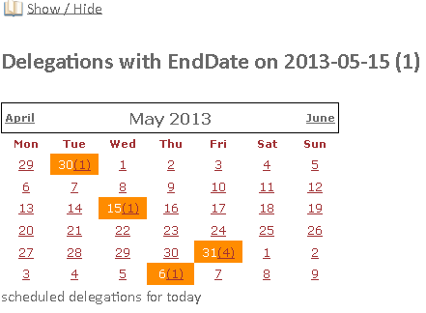

The calendar can be toggled on / off by pressing Show / Hide

For example, for 05/15/2013 there is one delegation with EndDate set to 05/15/2013

Clicking on the number in paranthesis displays the list with delegations for that day.



The page filters cam be reset by clicking againg search.

1. **Flights**

Holds informations about a flight operated on an airport:

- FlightNumber (mandatory)

- DepartureDate (mandatory)

- DepartureTime (mandatory)

- ArrivalDate (mandatory)

- ArrivalTime (mandatory)

- DepartureAirport (mandatory)

- ArrivalAirport (mandatory)

- FlagDel

- AirLine (mandatory)

A link to the TaxiBooking reservation made for this flight

a) Flights Filter

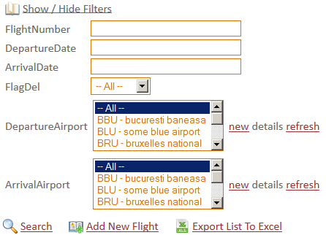

the list can be toggled on / off with the Show / Hide Filters option



The **Export List To Excel** exports the Flights list to Excel.

b) Add New Flight

- fill in the fields, marked with (*)

press Insert

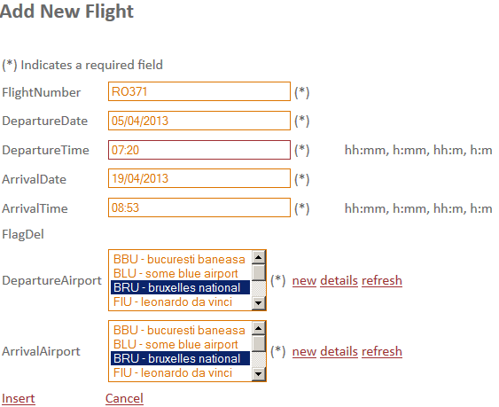

The new flight will be added to the list

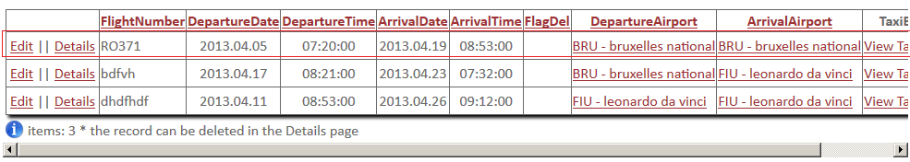

c) Flight Details

- Click on Details on the Flights List

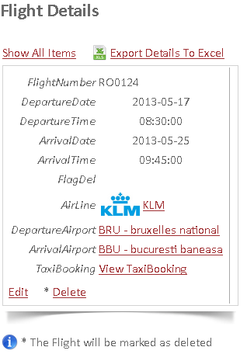

d) Edit Flight

- Can be done from the Flights List or from the Details page.

- fill in the mandatory Fields and click edit. A confirmation message will appear

e) Delete Flight

- click Delete on the Details page

- confirm the operation

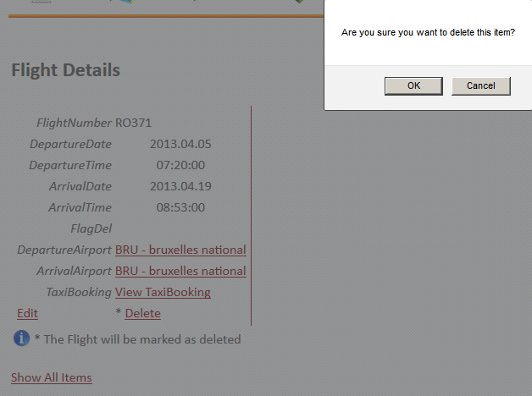

- the Flight will be marked as deleted

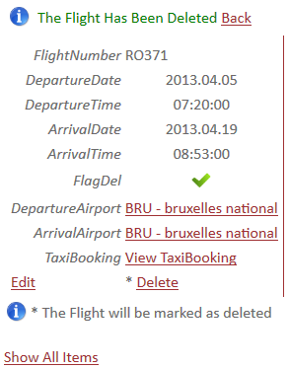

1. **Airports**

Holds informations about all airports:

- Code (mandatory)

- Name (mandatory)

- City (mandatory)

- Address (mandatory)

- ArrivalTime (mandatory)

- DepartureAirport (mandatory)

- ArrivalAirport (mandatory)

- FlagDel

A link to the TaxiBooking reservation made for this flight

a) Airports Filter

the list can be toggled on / off with the Show / Hide Filters option



The **Export List To Excel** exports the Airports list to Excel.

b) Add New Airport

- fill in the fields, marked with (*)

click-ing on the Google Maps icon , will open the location on Google Maps, on a new Page

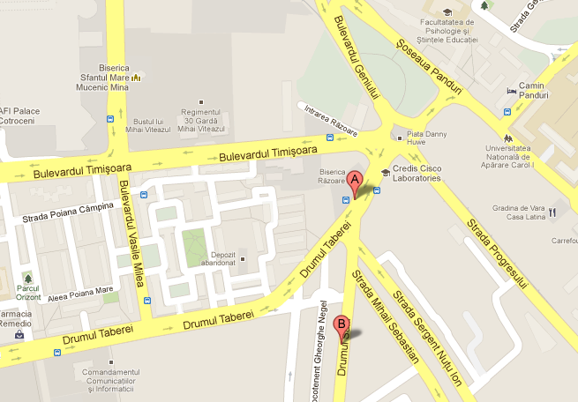

The same feature applies also in the Airports list

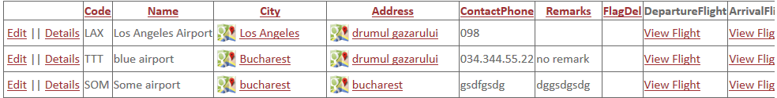

press Insert

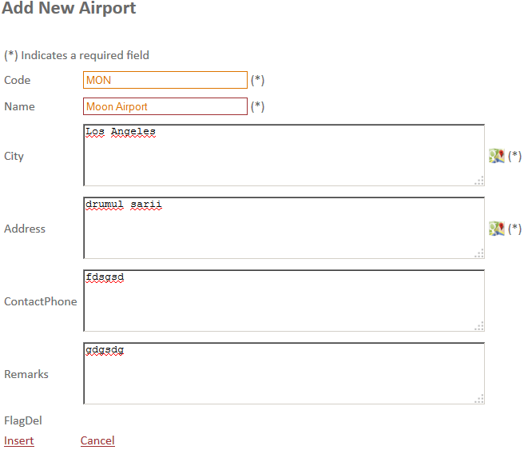

The new airport will be added to the list



c) Airport Details

- Click on Details on the Airports List

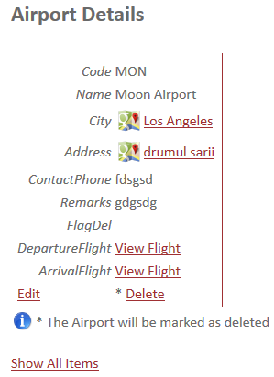

d) Edit Airport

- Can be done from the Airport List or from the Details page.

- fill in the mandatory Fields and click edit. A confirmation message will appear

e) Delete Airport

- click Delete on the Details page

- confirm the operation

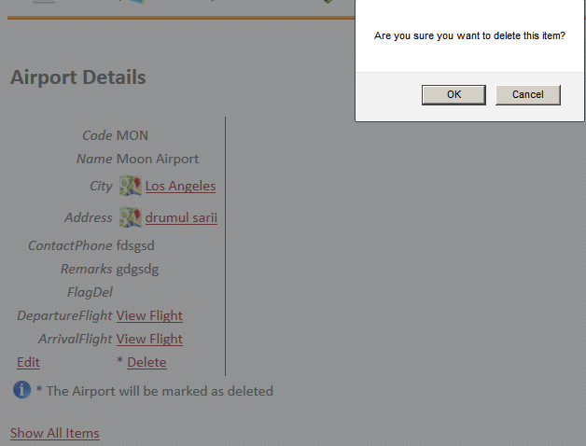

- the Airport will be marked as deleted

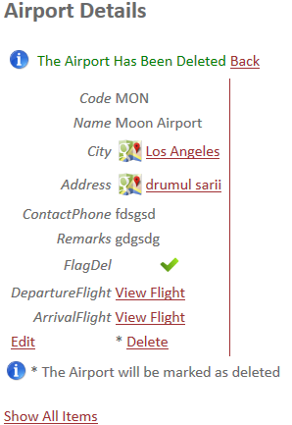

1. **AirLines**

Holds informations about all airlines:

- Name (mandatory)

- Picture (company logo)

- FlagDel

A link to the Flights operated by this AirLine

a) Airlines Filter

the list can be toggled on / off with the Show / Hide Filters option

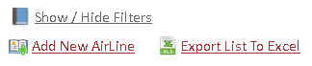

The **Export List To Excel** exports the AirLines list to Excel.

b) Add New AirLine

- fill in the fields, marked with (*)

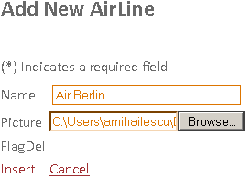

press Insert



The new airline will be added to the list



c) AirLine Details

- Click on Details on the AirLines List

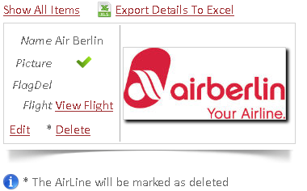

d) Edit AirLine

- Can be done from the AirLines List or from the Details page.

- fill in the mandatory fields and click edit. A confirmation message will appear

e) Delete AirLine

- click Delete on the Details page

- confirm the operation

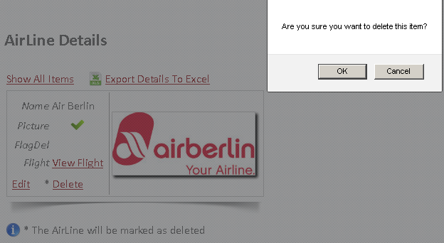

- the AirLine will be marked as deleted

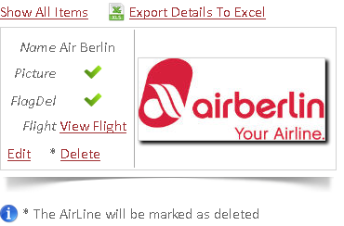

1. **Cost Centers**

Holds informations about all cost centers related to a delegation:

- Name (mandatory)

- ProjectCode (mandatory)

- BusinessUnit (mandatory)

- Reason (mandatory)

A link to the TaxiBooking reservation made for this flight

a) Cost Centers Filter

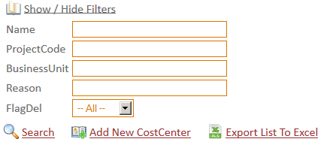

the list can be toggled on / off with the Show / Hide Filters option



The **Export List To Excel** exports the Cost Centers list to Excel.

b) Add New Cost Center

- fill in the fields, marked with (*)

press Insert

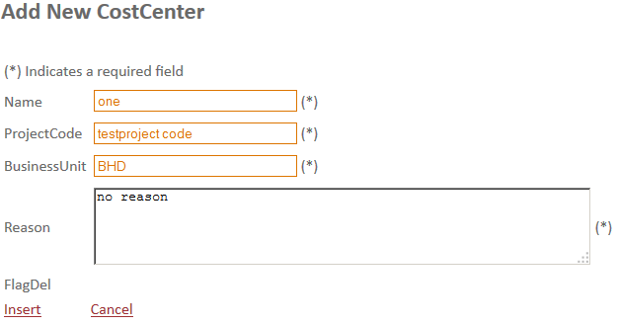

The new cost center will be added to the list

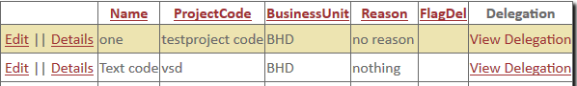

c) Flight Details

- Click on Details on the Flights List

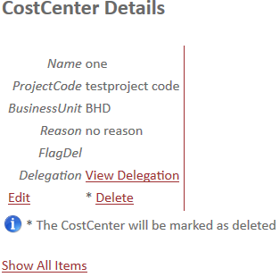

click on View Delegation to view delegations related to this Cost Center

d) Edit Cost Center

- Can be done from the Cost Centers List or from the Details page.

- fill in the mandatory Fields and click edit. A confirmation message will appear

e) Delete Cost Center

- click Delete on the Details page

- confirm the operation

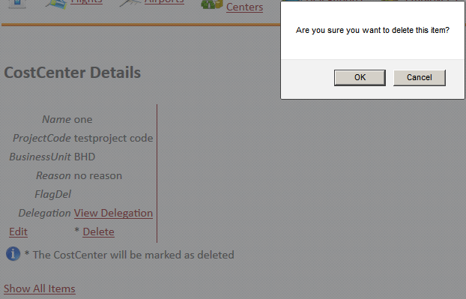

- the Cost Center will be marked as deleted

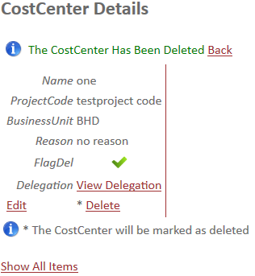

1. **Delegations**

Holds informations about all delegations related to an employee:

- Name (mandatory)

- StartDate (mandatory)

- EndDate (mandatory)

- Details (mandatory)

- A link to the TaxiBooking reservation made for this delegation

- A link to the CostCenter

- A link to the Employee

The TaxiReservationMade can’t be modified. It’s managed by the system and checks if this delegation has already been booked with a taxi reservation.



You cand add multiple instances of this delegation name, each one with a different CostCenter and Employee, as shown in the picture.

The TaxiReservationMade field will be left unchecked by the system, until you maka a taxi reservation for this delegation. After adding a taxi reservation, the field will be checked.



a) Delegations Filter

the list can be toggled on / off with the Show / Hide Filters option



The **Export List To Excel** exports the Cost Centers list to Excel.

b) Add New Delegation

- fill in the fields, marked with (*)

For a delegation, the Name field is used to group multiple Employees and CostCenters to a Delegation.

The Delegation’s ProjectCode, BusinessUnit and Reason cand be filled in th the CostCenter page.

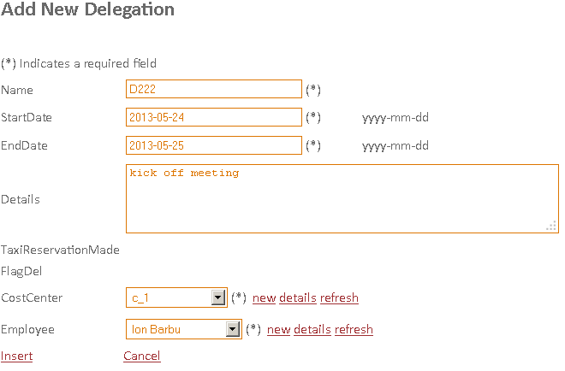

-press Insert

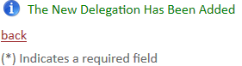

The new delegation will be added to the list

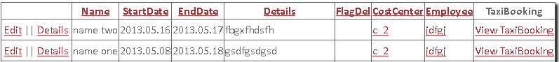

c) Delegation Details

- Click on Details on the Delegations List

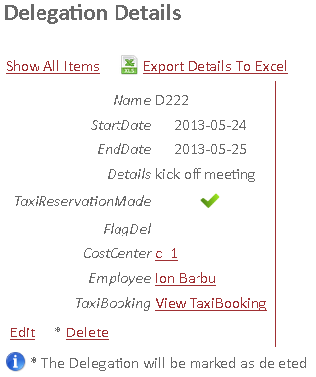

- click on View TaxiBooking to view Taxi Bookings related to this Delegation

- click on Employee to view informations about the employee that for this delegation

- click on CostCenter to view Taxi informations about the cost center for this delegation

d) Edit Delegation

- Can be done from the Delegations List or from the Details page.

- fill in the mandatory Fields and click edit. A confirmation message will appear

e) Delete Delegation

- click Delete on the Details page

- confirm the operation

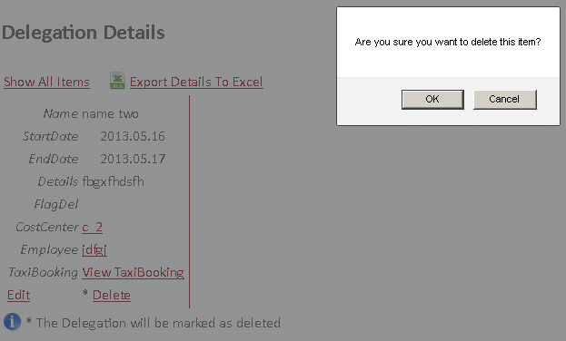

- the Delegation will be marked as deleted

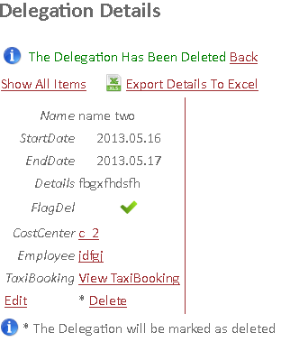

1. **Employees**

Holds informations about all employees engaged in delegations:

- Name (mandatory)

- PhoneNumber (mandatory)

- CNP (mandatory)

- Email (mandatory)

- FlagDel

- Picture

A link to the delegations available for this user.

a) Employees Filter

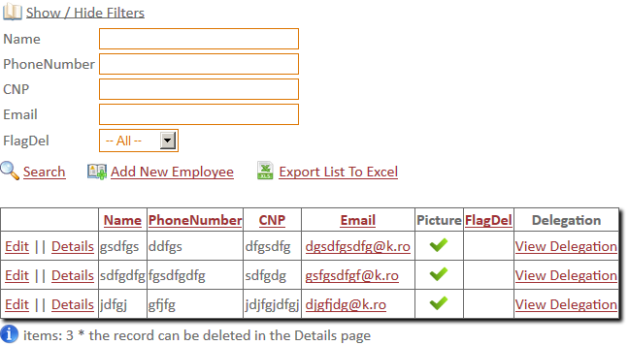

the list can be toggled on / off with the Show / Hide Filters option



The **Export List To Excel** exports the Cost Centers list to Excel.

b) Add New Employee

- fill in the fields, marked with (*)

-press Insert

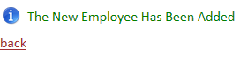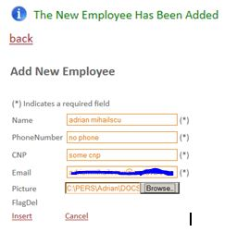

The new delegation will be added to the list

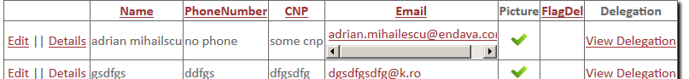

c) Employee Details

- Click on Details on the Employees List. If the employee has a picture attached, it will be shown

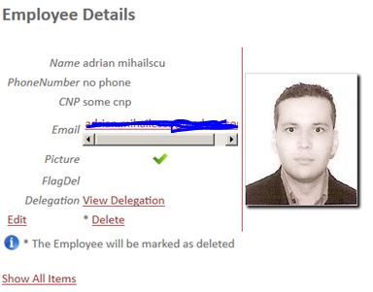

- click on View Delegation to view Delegations related to this user

d) Edit User

- Can be done from the Delegations List or from the Details page.

- fill in the mandatory Fields and click edit. (If the employee has a picture attached, it will be shown)

A confirmation message will appear

e) Delete User

- click Delete on the Details page

- confirm the operation

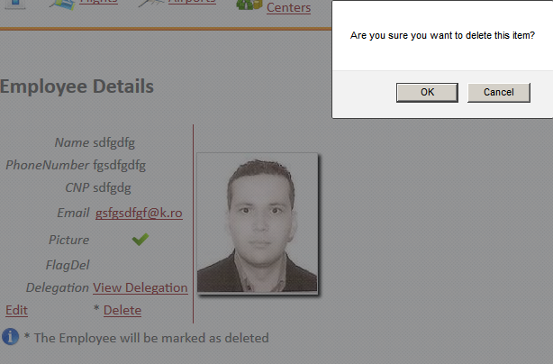

- the User will be marked as deleted

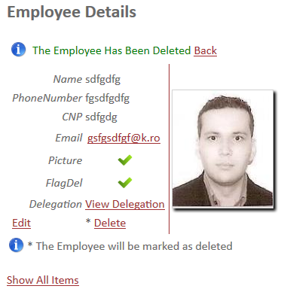

1. **Taxi Bookings**

Holds informations about all taxi reservations made for delegations:

- ReservationDate (mandatory)

- ReservationTime (mandatory)

- PickupAddress (mandatory) (click the Google Maps icon to see the location on map)

- DropAddress (mandatory)

- NumberOfPersons (mandatory)

- PassengersName (mandatory)

- Cost

- Currency

- Remarks

- FlagDel

- A link to the TaxiCompany used for this TaxiBooking

- A link to the Flight used by this Employee

- A link to the Delegation assigned to this Employee

a) TaxiBookings Filter

the list can be toggled on / off with the Show / Hide Filters option



The **Export List To Excel** exports the TaxiBookings list to Excel.

b) Add New TaxiBooking

- fill in the fields, marked with (*) (one person by line)

click-ing on the Google Maps icon , will open the location on Google Maps, on a new Page

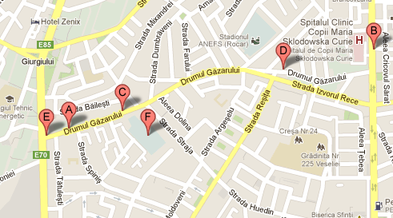

The same feature applies also in the TaxiBookings list

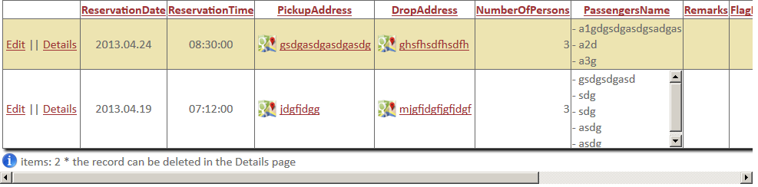

press Insert

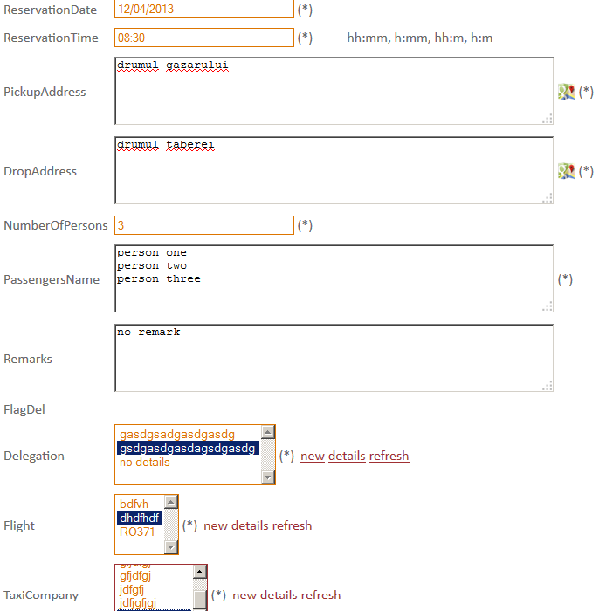

The new taxi booking will be added to the list

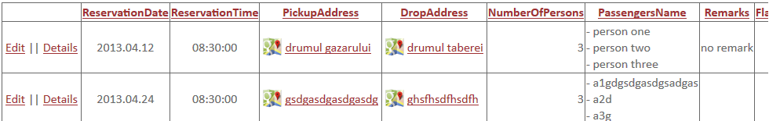

c) TaxiBooking Details

- Click on Details on the TaxiBookings List

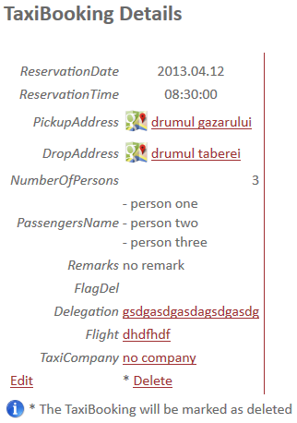

d) Edit TaxiBooking

- Can be done from the TaxiBookings List or from the Details page.

- fill in the mandatory Fields and click edit. A confirmation message will appear

e) Delete TaxiBooking

- click Delete on the Details page

- confirm the operation

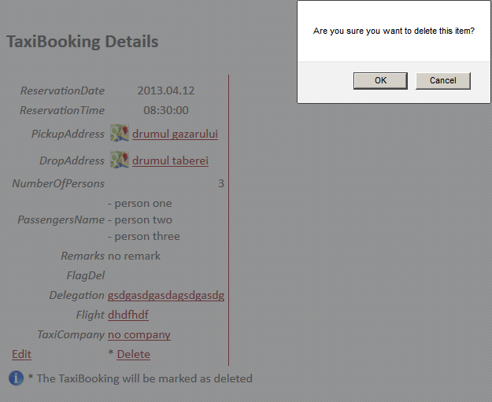

- the TaxiBooking will be marked as deleted

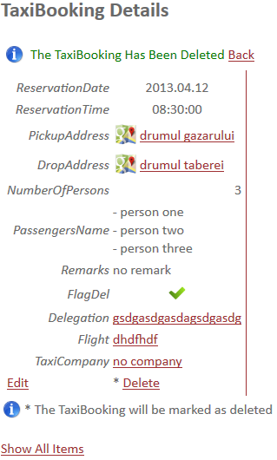

1. **Taxi Companies**

Holds informations about all operated taxi companies:

- Name (mandatory)

- PhoneNumber(mandatory)

- Address (mandatory) (click the Google Maps icon to see the location on map)

- Rating

- FlagDel

- A link to the TaxiBookings made to this company

a) TaxiCompanies Filter

the list can be toggled on / off with the Show / Hide Filters option



The **Export List To Excel** exports the TaxiBookings list to Excel.

b) Add New TaxiCompany

- fill in the fields, marked with (*) (one person by line)

click-ing on the Google Maps icon , will open the location on Google Maps, on a new Page



The same feature applies also in the TaxiCompanies list

press Insert

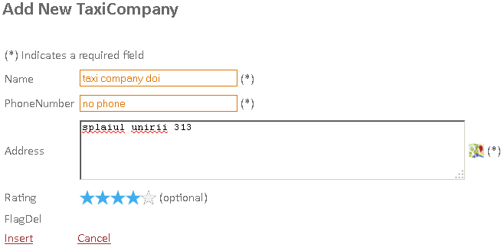

The new taxi Company will be added to the list

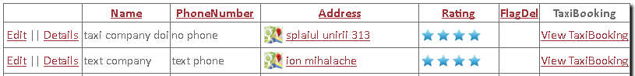

c) TaxiCompany Details

- Click on Details on the TaxiCompanies List

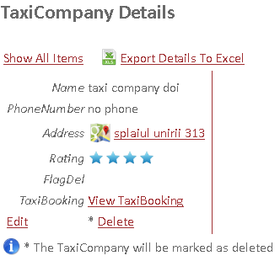

d) Edit TaxiCompany

- Can be done from the TaxiBookings List or from the Details page.

- fill in the mandatory Fields and click edit. A confirmation message will appear

e) Delete TaxiCompany

- click Delete on the Details page

- confirm the operation

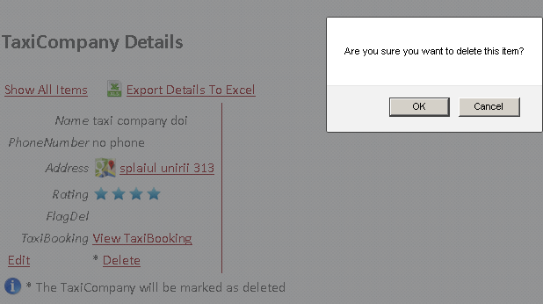

- the TaxiCompany will be marked as deleted

